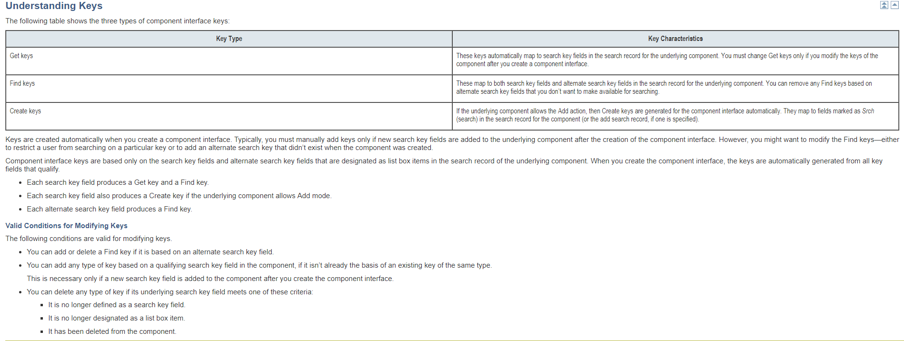

Understanding Standard Properties
Standard properties do not appear in the component interface view in PeopleSoft Application Designer. The following tables name and define the standard properties, and list the interfaces for PeopleCode, Java, C++, and Visual Basic.
This table contains the component interface properties:
Name | Description, Programming Syntax
CreateKeyInfoCollection | Returns a collection of items that describes the Create keys. This property is read-only.  Use these interfaces to call with other programming languages.  - Java: IcompIntfcPropertyInfoCollection getCreateKeyInfoCollection()  - C++: HPSAPI_COMPINTFCPROPERTYINFOCOLLECTION <CI_NAME>_GetCreateKeyInfoCollection(HPSAPI_<CI_NAME>)  - COM: CompIntfcPropertyInfoCollection CreateKeyInfoCollection
GetKeyInfoCollection | Returns a collection of items that describes the Get keys. This property is read-only.  Use these interfaces to call with other programming languages.  - Java: IcompIntfcPropertyInfoCollection getGetKeyInfoCollection()  - C++: HPSAPI_COMPINTFCPROPERTYINFOCOLLECTION <CI_NAME>_GetGetKeyInfoCollection(HPSAPI_<CI_NAME>)  - COM: CompIntfcPropertyInfoCollection GetKeyInfoCollection
FindKeyInfoCollection | Returns a collection of items that describes the Find keys. This property is read-only.  Use these interfaces to call with other programming languages.  - Java: IcompIntfcPropertyInfoCollection getFindKeyInfoCollection()  - C++: HPSAPI_COMPINTFCPROPERTYINFOCOLLECTION <CI_NAME>_GetFindKeyInfoCollection(HPSAPI_<CI_NAME>)  - COM: CompIntfcPropertyInfoCollection FindKeyInfoCollection
GetHistoryItems | Controls whether the component interface runs in Update/Display mode or Update/Display All mode when the underlying component is effective-dated. If GetHistory is set to true, then historical data can be retrieved but not modified. GetHistory items work in accordance with EditHistory items.  The default value is False. This property is read-only.  Use these interfaces to call with other programming languages.  - Java: boolean getGetHistoryItems(), void setGetHistoryItems(boolean)  - C++: BOOL <CI_NAME>_GetGetHistoryItems(HPSAPI_<CI_NAME>), void <CI_NAME>_SetGetHistoryItems(HPSAPI_<CI_NAME>, BOOL)  - COM: Boolean GetHistoryItems
EditHistoryItems | Controls whether the component interface runs in Update/Display All mode, Update/Display mode, or Correction mode when the underlying component is effective-dated. If EditHistory items are set to true, then historical data can be modified. EditHistory items work in accordance with GetHistory items.  The default value is False. This property is read-only.  Use these interfaces to call with other programming languages.  - Java: boolean getEditHistoryItems(), void setEditHistoryItems(boolean)  - C++: BOOL <CI_NAME>_GetEditHistoryItems(HPSAPI_<CI_NAME>), void <CI_NAME>_SetEditHistoryItems(HPSAPI_<CI_NAME >, BOOL)  - COM: Boolean EditHistoryItems
InteractiveMode | Controls whether to apply values and run business rules immediately, or whether items are queued and business rules are run later, in a single step.  Note. You should use interactive mode when testing and debugging a component interface. Interactive mode in a production environment slows performance because of the number of server trips required.  If you are using a component interface as part of a batch process in which thousands of rows are to be inserted, running in interactive mode may reduce performance so much on some UNIX servers that the application times out with a connection failure.  The default value is False. This property is read-only.  Use these interfaces to call with other programming languages.  - Java: boolean getInteractiveMode(), void setInteractiveMode(boolean)  - C++: BOOL <CI_NAME>_GetInteractiveMode(HPSAPI_<CI_NAME>), void <CI_NAME>_SetInteractiveMode(HPSAPI_<CI_NAME>, BOOL )  - COM: Boolean InteractiveMode
StopOnFirstError | When this property is set to True, the first error generated by the component interface halts the program.  The default value is False. This property is read-only.  - Java: boolean getStopOnFirstError(), setStopOnFirstError(boolean)  - C++: BOOL <CI_NAME>_GetStopOnFirstError(HPSAPI_<CI_NAME>), void <CI_NAME>_SetStopOnFirstError(HPSAPI_<CI_NAME>, BOOL)  - COM: Boolean StopOnFirstError
CompIntfcName | Returns the name of the component interface class as named in PeopleSoft Application Designer. This property is read-only.  - Java: String getCompIntfcName()  - C++: LPTSTR <CI_NAME>_GetCompIntfcName((HPSAPI_<CI_NAME>)  - COM: String GetCompIntfcName
ComponentName | Returns the name of the component interface class as named in PeopleSoft Application Designer. This property is read-only.  - Java: boolean getComponentName()  - C++: LPTSTR <CI_NAME>_GetComponentName(HPSAPI_<CI_NAME>)  - COM: Boolean GetComponentName
Description | Returns the description of the component interface class as set in PeopleSoft Application Designer. This property is read-only.  - Java: boolean getDescription()  - C++: LPTSTR <CI_NAME>_GetDescription((HPSAPI_<CI_NAME>)  - COM: String Description
Market | Returns the Market setting of the component used to build this component interface. This property is read-only.  - Java: String getMarket()  - C++: LPTSTR <CI_NAME>_GetMarket((HPSAPI_<CI_NAME>)  - COM: String Market
GetDummyRows | When a new scroll is inserted on a page, that scroll is displayed even though it has no underlying data. Any scroll that is empty has one dummy row displayed with only the defaults set. This property is True if the dummy row is to be displayed, False if it is not. The default value for this property is True. This property is read-write.  - Java: boolean getGetDummyRows(), void setGetDummyRows(boolean)  - C++: BOOL <CI_NAME>_GetGetDummyRows(HPSAPI_<CI_NAME>), void <CI_NAME>_SetGetDummyRows(HPSAPI_<CI_NAME>, BOOL)  - COM: Boolean GetDummyRows
PropertyInfoCollection | Returns a collection of items that describes a specific property. The specific properties that are available in the propertyinfocollection are listed here. This property is read-only.  Use these interfaces to call with other programming languages.  - Java: IcompIntfcPropertyInfoCollection getPropertyInfoCollection()  - C++: HPSAPI_COMPINTFCPROPERTYINFOCOLLECTION <CI_NAME>_GetPropertyInfoCollection(HPSAPI_<CI_NAME>)  - COM: CompIntfcPropertyInfoCollection PropertyInfoCollection

Understanding Standard Methods
A method is a definition that performs a specific function on a component interface at runtime. Each standard method is added by default when the component interface is created and is available in PeopleCode and other programming languages. Like properties, methods are saved as part of a component interface definition. Two main types of methods are available: standard methods and user-defined methods.
Standard Methods | Description, Programming Syntax
Cancel | Backs out of the current component interface, canceling any changes made since the last save. This is equivalent to clicking the Return to Search button online. Returns True on success, and False on failure.  Use these interfaces to call with other programming languages.  - Java: boolean cancel()  - C++: BOOL <CI_NAME>_Cancel(HPSAPI_<CI_NAME> hObj)  - COM: Function Cancel() As Boolean
Create | Creates a new instance of a component interface. This is equivalent to creating a new record in Add mode online. Returns True on success, and False on failure.  Use these interfaces to call with other programming languages.  - Java: boolean create()  - C++: BOOL <CI_NAME>_Create(HPSAPI_<CI_NAME> hObj)  - COM: Function Create() As Boolean
Find | Performs a partial key search for a particular instance of a component interface, using the search keys at level 0. Returns a collection of component interface instances which match the search criteria. If no component interface instances match the search criteria, the count on the collection is zero.  Use these interfaces to call with other programming languages.  - Java: <CI_NAME>Collection find()  - C++: HPSAPI_<CI_NAME>COLLECTION <CI_NAME>_Find(HPSAPI_<CI_NAME> hObj)  - COM: Function Find() As <CI_NAME>Collection
Get | Retrieves a particular instance of a component interface. This is equivalent to opening a record in Update/Display or Correction mode when online with a PeopleSoft application. Returns True on success, and False on failure.  Use these interfaces to call with other programming languages.  - Java: boolean get()  - C++: BOOL <CI_NAME>_Save(HPSAPI_<CI_NAME> hObj)  - COM: Function Get() As Boolean
Save | Saves an instance of a component interface. This is equivalent to clicking the Save button in the online system. Returns True on success, and False on failure. You should cancel after a save.  Use these interfaces to call with other programming languages.  - Java: boolean save()  - C++: BOOL <CI_NAME>_Save(HPSAPI_<CI_NAME> hObj)  - COM: Function Save() As Boolean
GetPropertyByName | Returns the value of a property that is specified by name. This function typically is used only in applications that cannot get the names of the component interface properties until runtime.  Use these interfaces to call with other programming languages.  - Java: Object getPropertyByName(String str)  - C++: HPSAPI_OBJECT <CiCollectionItem>_GetPropertyByName(HPSAPI_<CI_COLLECTION_ITEM> hColItem, LPTSTR Name)  - COM: Function GetPropertyByName(name As String)
SetPropertyByName | Sets the value of a property that is specified by name. This function typically is used only in applications that cannot set the names of the component interface properties until runtime.  Use these interfaces to call with other programming languages.  - Java: long setPropertyByName(String str, Object o)  - C++: PSI32 <CiCollectionItem>_SetPropertyByName(HPSAPI_<CI_ COLLECTION_ITEM> hColItem, LPTSTR name, HPSAPI_OBJECT Value)  - COM: Function SetPropertyByName(name As String, value) As Long
GetPropertyInfoByName  (In PeopleCode, CompIntfPropInfoCollection) | Returns specific information, such as length, about the definition of a property that is specified by name. This function typically is used only in applications that cannot get the names of component interface properties until runtime or by applications that need to provide a dynamic list of values that would normally be found in prompt tables.  Use these interfaces to call with other programming languages.  - Java: IcompIntfcPropertyInfo getPropertyInfoByName(String name)  - C++: HPSAPI_COMPINTFCPROPERTYINFO<CiPropOrItem>_GetPropertyInfoByName(HPSAPI_<CIPROPORITEM> hPropOrItem, LPTSTR name)  where CiPropOrItem is the name of either a property or an item in a collection.  - COM: Function GetPropertyInfoByName(name As String) As CompIntfcPropertyInfo  See CompIntfPropInfoCollection Object Properties.
By default, each component interface is created with four standard methods—Cancel, Find, Get, and Save. Additionally, the Create standard method is generated if Create keys have been added to the component interface.

How to Test Component Interfaces

Microsoft BizTalk Adapter for PeopleSoft Enterprise uses PeopleSoft metadata and component interfaces; therefore, it can handle new or modified component interfaces. The adapter makes no assumptions about component interfaces except that they are logical and valid. Therefore, each component interface must be tested before it is used as a source for the adapter.
If changes are made to the underlying application by the user or by a PeopleSoft upgrade, and the changes invalidate a component interface, the user must repair the invalid component interface before the adapter uses it.

To test a component interface
- In Application Designer, on the Tools menu, click Test Component Interface.
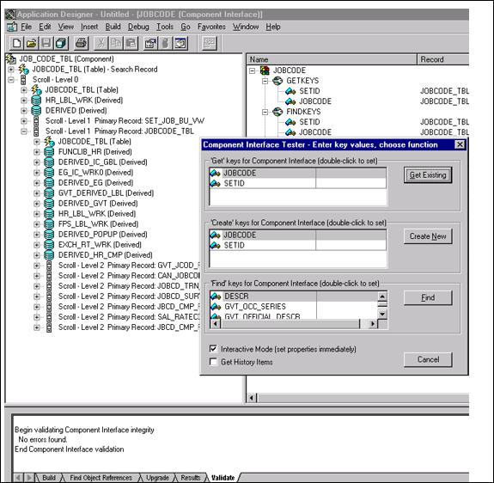
- In the Component Interface Tester dialog box, test the component interface by using one the following methods. After you finish making changes, right-click the top item in the pane.
Note
If required, click the dialog box to bring it to the foreground.
  - To test the component interface using the Find method, click Find.
The Component Interface Tester - Find Results dialog box opens, displaying all the possible entries for the underlying component. If there are more than 300 entries, a message appears.
a. In the left pane of the Find Results dialog box, select a field.
b. To display the relevant data for that particular field, click Get Selected.
The following screen appears.
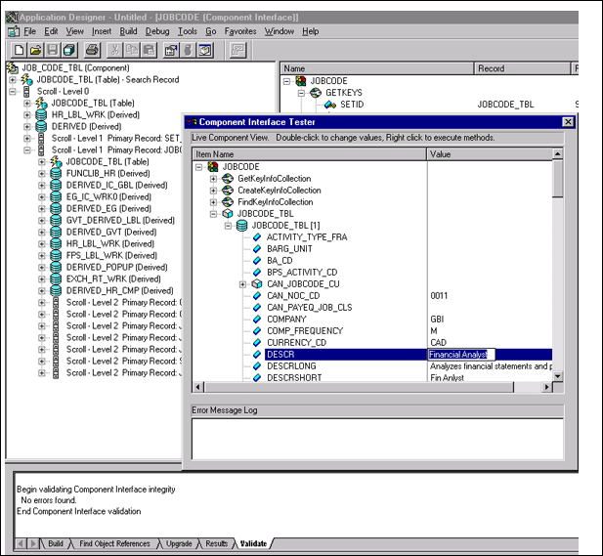

If the security settings allow, you can change the values in the individual fields.
The following dialog box opens.
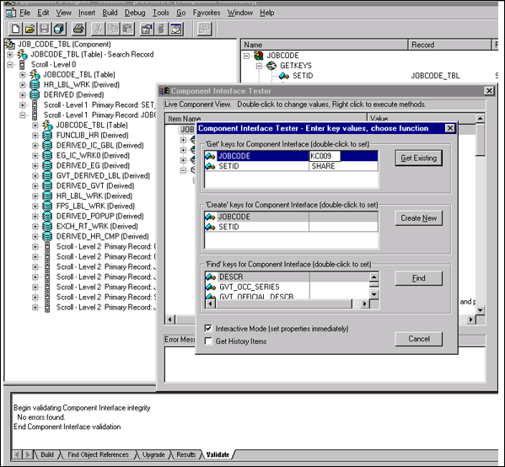
  - To test the component interface using the Get method:
a. Enter the existing key(s).
b. Click Get Existing.
This returns the exposed properties for the key that you entered.
You can change values if Update access was specified.
Alternatively, you can test using the Create method.
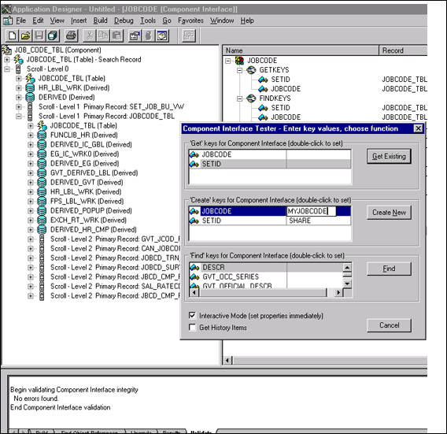
  - To test the component interface using the Create method:
a. Enter all required key values.
b. Click Create New.
When you enter valid values in Create keys, a pane that displays the JOBCODE data opens after the Table name is expanded with default data in place.
You can change fields now.
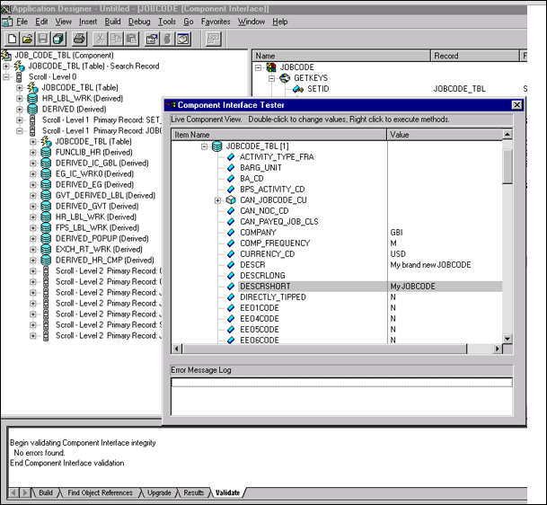
Changes are validated against the component's underlying business logic.
- To save your changes, click the Save icon.
The keys used to create the record can be used with the Get method for viewing data. The data that was added can be viewed in the PeopleSoft Component as shown in the following example.
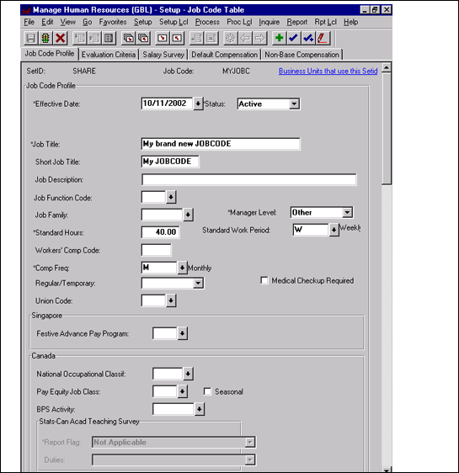
Effective Date is one of the default values.

